**TEST CASE 2: Create a login-ID test case (fail)**

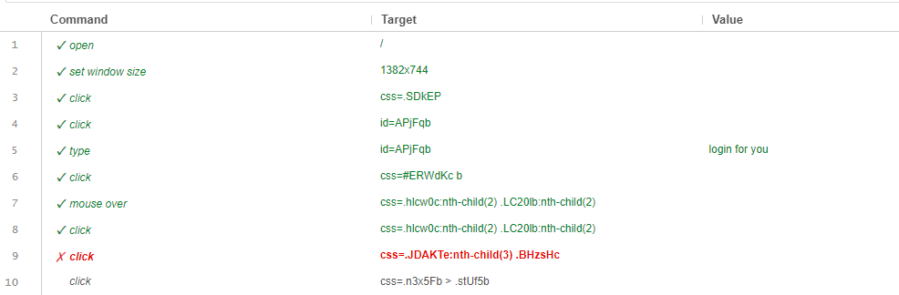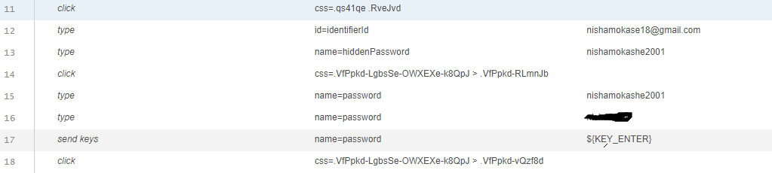

**OUTPUT:-**

